Case-Based Discussion Session Faculty
Presentation Guide

CONTENTS
Page
- Introduction …………......... 1
- Important Dates ……………….. 1
- Frequently Asked Questions ……. 1
- Box.com Tips ……………….. 2
- Learning Objectives……………….. 5
- Tips for Engaging the Audience … 5
- PowerPoint Presentation ……… 6
- ARS Questions ………………..10

- INTRODUCTION
Welcome and thank you for agreeing to participate as expert faculty for the Case-Based Discussion sessions of the CHEST annual meeting. These sessions are extremely popular and attendee reviews indicate that audience members appreciate the time you spend making a high-yield, interactive presentation. Please use this guide as an additional resource to help you develop your content so both you and your audience enjoy the conference as much as possible.

This tool has tips on creating and delivering successful presentations including slide design, writing audience response (ARS) questions, and interacting with the audience.

Again, we welcome and thank you for your time and dedication to what we expect will be another successful annual meeting.

- IMPORTANT DATES

April Invitations are sent to proposed faculty

August 28, 2020 Rough draft of presentation is due
This seems early, but a lengthy behind-the-scenes process begins at this time. Because most sessions have multiple presenters, rough draft presentations are reviewed by the session chair to avoid significant content duplication and ensure presenters are planning a reasonable amount of content for their part of the session. It is also an opportunity for presenters to get some feedback on slide design and audience participation tools.

October 2, 2020 Final presentation is due
The IT team needs several weeks to ensure the Audience Response Questions (the “I” in Interactive!) are properly integrated into the PowerPoint slideshows so you can avoid technical difficulties in front of 50 to 200 people. That is a good thing.

- FREQUENTLY ASKED QUESTIONS

What is a Case-based Discussion session? These sessions are focused sessions designed to maximize learner involvement by using a case-based format to drive discussion and audience participation, either by direct interaction with the presenter or using audience-response system (ARS) technology in larger meeting rooms.

What will be available in the room? All rooms will have a projector/computer input as well as the audience response system (ARS) software, and microphones to use with audience members. Your PowerPoint presentation will be loaded and ready for use with the ARS. Audience members will use their phones to respond to your questions.

How long will the session run? All sessions are in a 60-minute slot - in order to maximize audience participation and set up the ARS, you should plan for 45 minutes of session time. That will leave 15 minutes for spontaneous discussion or questions, which are encouraged in these sessions.

We have three faculty members on the session. How should it be organized? Your session chair should coordinate with the faculty members on the session format. Most sessions have each faculty present a single case, and others have used a pro/con style discussion using more than one faculty member for a single case. Whatever the format, keep in mind the time constraints and desired learning objectives- for three cases/presenters in 1 hour, each presenter will only have about 15 minutes. These sessions work best when presenters focus on “quality over quantity” in terms of slide number and content. Try to anticipate time for audience members to ask questions during or after the cases, and encourage the audience to do so.

What makes for the best use of the ARS? You can use the ARS to identify areas of your presentation on which the audience would like to spend the most time in discussion. Get to know who is in your audience and learn of their experiences. Use polling to determine practice gaps. or questions to determine knowledge gaps. If you would like additional examples or assistance with integrating audience response into your presentation, please contact CHEST.

- LEARNING OBJECTIVES
Setting explicit learning objectives at the beginning of your presentation is a great way to organize the flow of your talk. Define your objectives using active, measurable terms such that learners (and you) can assess whether the information has been imparted successfully.

For example, instead of a general objective like:
“Learn about the management of ARDS” or
“Be familiar with ventilator mode options for ARDS”

Use specific, active terms:
“At the end of this presentation, the learner will be able to describe the mechanism, benefits and risks of three different ventilator modes in ARDS”

- TIPS FOR ENGAGING THE AUDIENCE
It can be challenging to have a truly interactive session with a large audience. The rest of this document discusses good slide design and audience response questions. These are a great start to a dynamic presentation; to take yours to the next level, consider a few these ideas:
- Make eye contact. Choose a few individuals around the room with friendly faces and look directly at them from time to time. This not only creates a connection with the audience, it can help settle nervous speakers as well.
- Be personal: Using clinical cases allows the audience to imagine what they are learning in the context of their own practice. You can further signal to the audience that you identify and connect with them by describing your own personal practice by using phrases like “when we see this,” or “I tend to…”
- Move around (a little). A speaker who uses occasional hand gestures or takes a few steps is more engaging than one who stands perfectly still gripping the podium.
- Speak clearly. If you tend to be a “fast talker” or feel nervous in front of a crowd, make a conscious effort to slightly slow your speech.
- Use humor. This can be tricky- overt jokes often fall flat, and remember that CHEST is an international audience; funny doesn’t always translate. But the best medical talks aren’t dreary affairs; it’s ok to make an occasional lighthearted or overtly funny comment. If you’re having fun yourself, there is a good chance your audience will not only learn something from you, but enjoy themselves in the process.
- Practice your delivery. In front of a mirror is good, in front of an audience is even better. Ask someone you trust to give you honest feedback about your slide design, timing, and how you look and sound.
- Encourage questions. It takes a brave soul to raise a hand in a room full of people. Build some extra time into your talk and invite audience members to ask questions during your presentation, rather than just saving questions to the end. These spontaneous moments can lead to unexpected, interesting discussion.
- Use other methods of direct audience participation. These can be challenging but are unexpected and can be very successful.
- Ask questions: “someone shout out what they notice about this CT.” Plant a friend to speak up if no one answers in a few seconds, and get the ball rolling.
- Use audience discussion- pose a question and ask the audience members to turn to their neighbors and discuss for 30 seconds before taking a brief hand-raising poll.
- Ask the audience to do some work. “Everyone grab a pen, and write down the first three things that come to your mind when I say ___” You don’t have to get their responses, but it will get them thinking more actively rather than simply waiting for you to teach them.

- POWERPOINT PRESENTATIONS
It is extremely important that presentations be submitted by the designated due date because the audience response questions require the IT team to integrate a separate software program well in advance of the meeting. If presentations are changed at the last minute, the ARS questions will not align with the presentation slide order.

TEN TIPS FOR HIGH-IMPACT SLIDES
- Use the provided template that is uploaded into your Box folder. See below for details
- Keep text succinct; avoid unnecessary verbiage. Learners will listen to you rather than read your slides, and will retain the information better
- Where possible, use charts, images and videos to explain the information.
  - Adding graphics helps students learn better, with 65% of students performing better on a test that contained both words and graphics compared with 38% that used words only. (Richard Mayer, Ruth Clarke, “E-Learning and the Science of Instruction”)
- Use text animations wisely to highlight important information; when overused they can be distracting
- Keep file size manageable by compressing images (see below)
- Use full-sentence headlines written as an assertion.
  - Students are better able to recall the main assertion of slides when presented with a full-sentence headline compared to a word or phrase headline. (Alley, M., Schreiber, M., Ramsdell, K., & Muffo, J. (2006). How the Design of Headlines in Presentation Slides Affects Audience Retention. Technical Communication, 53, 225-234.)
- No more than two graphics per slide
- Use a maximum of three slides per minute
- Include one clinical case and one to two audience response questions approximately every 15 minutes. Most CID sessions will use two to three clinical cases for a 60minute session

TEMPLATES
If you are writing your presentation from scratch, develop it on the CHEST template we have provided you. If you are modifying an existing presentation from a different template, you can convert it to the CHEST template one of two ways:

Method One: Import your presentation into the CHEST template:
- Open the blank CHEST template

- Under the “New Slide” or “Insert New Slide” icon in your version of Powerpoint, select the option that allows you to import slides from another presentation. In Powerpoint 2010, this option is “Reuse slides”

- A popup menu will appear allowing you to choose the source of the new slides. Select “Browse” and then “Browse File…” to browse through your computer folders

- Double-click on the presentation you want to import

Method Two: Apply the CHEST template to your preexisting slides:
1. Save the template from the Box folder onto your computer
2. Open your current presentation
3. On the top tab bar, click “Themes”

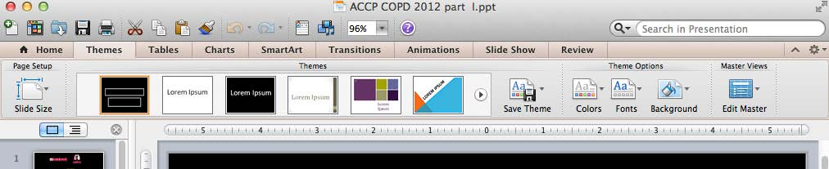

4. Holding your mouse over the theme samples, click on the down arrow that appears.

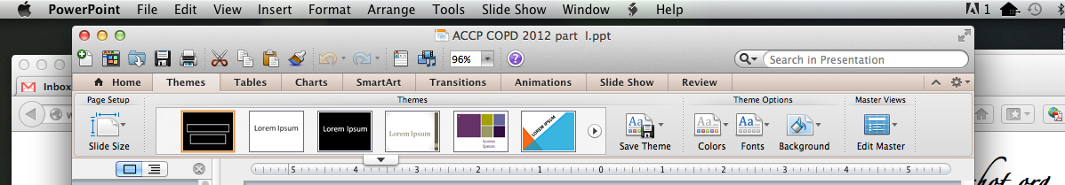

5. Click on “Browse Themes” at the bottom of the drop-down box that appears.

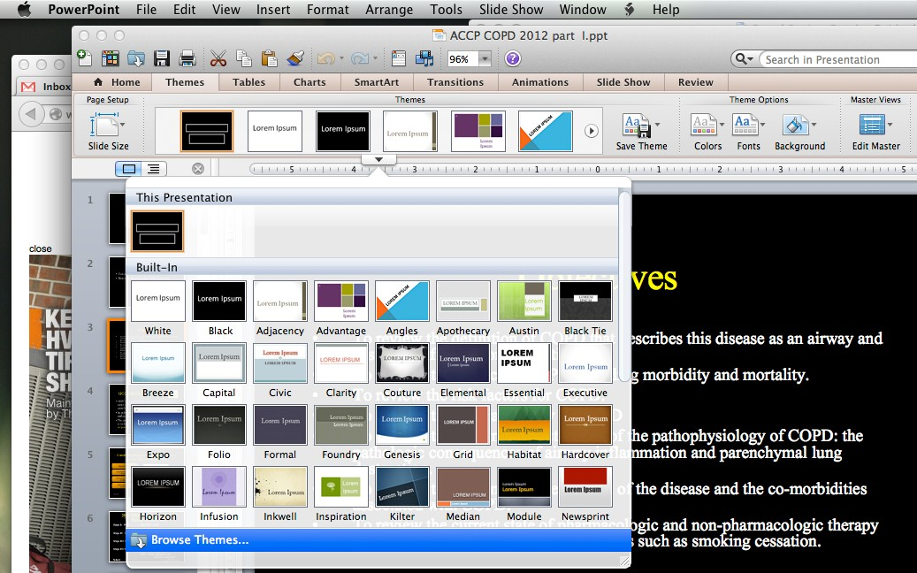

6. Find the CHEST template on your computer, highlight the template and click apply. If the template file is greyed out, make sure the “Enable” box says “PowerPoint Presentations.” (The example below is for a Board Review template)

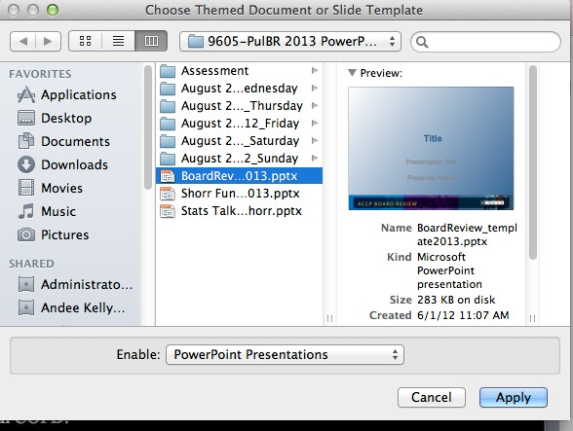

7. Your personal presentation slides should change over to the CHEST template. You will need to do some reformatting

COMPRESSING AN IMAGE:
Compressing images will shrink the size of the image, allowing you to decrease the overall size of your presentation for faster upload times.
1. Click or highlight the image on the slide.
2. Select “Format Picture” on the top tab bar.

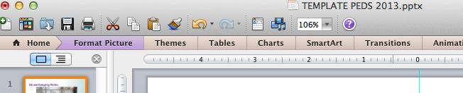

3. Choose “Compress” from the list of options

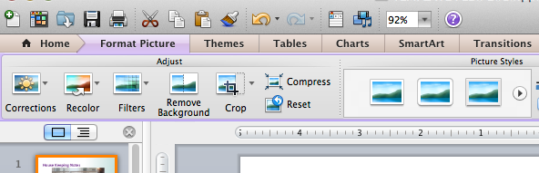

4. For the “Picture Quality,” select “Best for viewing on screen (150 ppi) from the dropdown menu. Make certain the “All pictures in this file” is selected. Click “Ok”

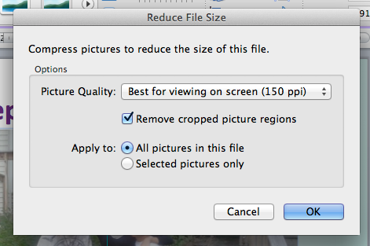

- TIPS FOR WRITING AUDIENCE RESPONSE QUESTIONS

Using ARS questions in your presentation allows you to:
- Set the stage for the next part of your talk
- Assess the audience’s level of knowledge on a topic
- Identify areas of knowledge gap to focus on as you proceed through your case. Conversely, if the audience does very well on a question about a certain topic, you may decide to abbreviate your discussion of the basics and focus on more recent research or areas of controversy.
- Keep the audience awake by engaging them!
- For technical purposes, make sure when creating your slides, the questions and answers are on one slide and the next slide will have the correct answer highlighted.

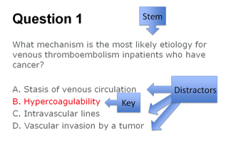
Anatomy of a test question:
The Stem:
- Contains the statement or question
- Should be simple and plainly written. No trick questions.
- Should focus on one bit of behavior, task or learning objective
- Avoid “True/False” questions, as they don’t adequately assess learner’s knowledge

The Key:
- The best or most appropriate of the available responses.

The Distractors:
- Comparatively worse choice than the key, but need not be absolutely incorrect
- Avoid using “All of the above” or “none of the above”
- All distractors should be written in the same way with similar length, detail and grammatically consistent

Keep in mind that with a live audience, you don’t have to strictly apply these “rules.” Many presenters use ARS questions to assess knowledge as above, but you can also inject a little humor, or include more than one “right” answer to stimulate discussion.

