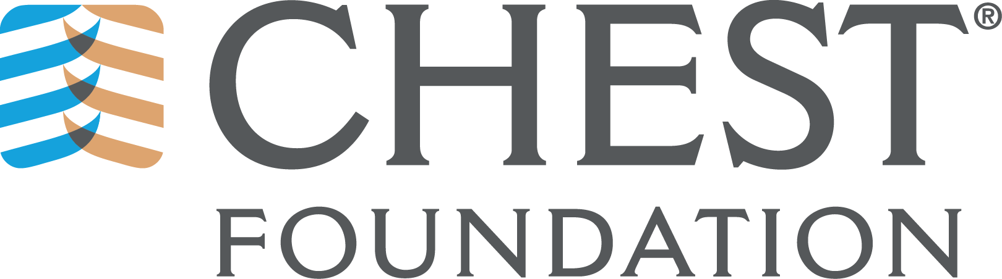

Presidential Candidate Issue Analysis

Please indicate what you see are the top 5 key issues of concern for the Foundation. Explain how plan to address these key issues by providing solutions:

1.

2.

3.

4.

5.

Please send back to Suzanne Sletto (ssletto@chestnet.org) by July 31, 2019.

